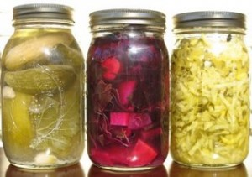
Honors Assignment #4: Fermentation
The Science of Traditional Craft

Activity modified from http://edtech2.boisestate.edu/christinamoore3/502/webquest/start.html

Your task is to choose a fermented food item and assemble a "recipe" for home production. This could include yogurt, sauerkraut, sour cream, wine, beer, etc!
Your recipe must be in the form of written directions for product production and include:
- Background information about the fermenter used; for example, which strains of Lactobacillus you will use to make yogurt, where it can be obtained, etc.
- The equipment needed for production.
- The materials needed for production.
- The process you will use to produce your product.
- How you will judge the quality and safety of your product.

There are 4 general areas that must be researched and included in your paper:
- Research your food and its production process. Include in your background information a description of the process of fermentation, the type of organism used to achieve fermentation (bacteria, yeast), what the common strains are, and where they can be purchased or found.
- Determine what equipment and materials you will need to use to produce your product, where they can be purchased (name of store, website link), and the approximate cost.
- Create a step-by-step procedure for producing your product. Begin by listing the materials and equipment needed, break down the process into steps, and estimate the time needed to accomplish each step.
- Identify the process and materials you will use to determine the safety of your product (you do NOT want to eat spoiled yogurt or sauerkraut). You cannot just "taste" for safety, you will need to use a method that can measure and detect any potential contamination.

A list of resources must be included on a works cited page at the end of the paper.

